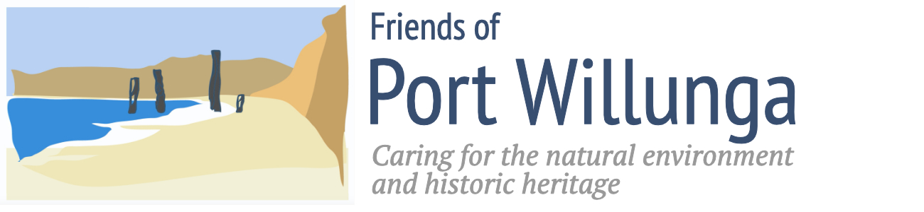

Incorporation Number A36490

NOTIFICATION OF THE

FRIENDS OF PORT WILLUNGA INC.

ANNUAL GENERAL MEETING

11am SUNDAY 22nd January 2023

at the Aldinga Institute Hall

Old Coach Road, Aldinga

Please come along and welcome guest speaker
Moira Were AM
Mayor, City of Onkaparinga

Moira has worked from the kitchen table as a social worker through to the cabinet table as ministerial chief of staff. She has extensive strategic and operational experience in the not-for-profit sector and in government at state, regional, national & international levels. Moira received an Australian honour in 2019 (AM) for her significant service to the community of South Australia and was elected Mayor of the City of Onkaparinga in the 2022 local government elections.

All welcome but please RSVP to Janie Freeman: jane.freeman@hotmail.com
We encourage existing members to renew their membership online https://friendsofportwillunga.org.au/join-donate/ ahead of the AGM.
New members can also join online or at the AGM.

