McLaren Vale’s famous farmland could be broken up for low quality houses, a local MP warns, but the government rejects his claims of a “sneaky” rules review.

Elizabeth Henson

McLaren Vale residents fear a State Planning Commission review of character preservation zones could lead to prime agricultural land in their town being turned into housing estates.
Mawson MP Leon Bignell says locals are worried such a move will cripple the popular food and wine region’s $850 million a year tourism industry and destroy its amenity.
The commission is currently undertaking a statutory review of the state’s Environment and Food Production Areas, which were introduced to safeguard vital agricultural land from urban encroachment.
As part of this audit, the commission is also assessing eight Character Preservation Districts, including McLaren Vale. CPD legislation protects the rural amenity, character and scenic vistas of specified tourism areas by ensuring any future development does not detract from dominant land uses.
The commission itself is not able to alter CPD boundaries so any recommendations it makes in relation to these will need to be approved by state parliament before they can take effect.
The review has been released for public consultation.
Mr Bignell said residents were concerned the assessment was the first step towards changing the CPD boundaries around McLaren Vale, which would pave the way for developers to seek to rezone large parcels of agricultural land off Aldersey St and turn them into housing estates.
“What we’ve seen from most developers in Adelaide is that they get greenfield sites and cover them in low-quality s*** housing,” he said.
“We’ve got nowhere to grow food if we don’t start protecting it.”

Mawson MP Leon Bignell. Picture: Twitter

Mr Bignell claimed the state government was “sneakily” using the review of the EFPAs to also look at amending character preservation areas, saying the Liberals were “always eager to look after their developer mates more than the people of our area”.
He is holding a public meeting to discuss the review on Wednesday at 6pm in the Tatachilla Lutheran College gym. RSVPs are essential due to Covid restrictions.
A previous review of CPDs in 2018 prompted 500 McLaren Vale residents to attend a public meeting, organised by Mr Bignell, to voice their opposition to any changes to the boundaries.
Dudley Brown, 58, owns Inkwell Wines and boutique accommodation Hotel California Road. He said it would be “terrible” if the parcels of land were subdivided for housing.
“It would be bad for tourism and it would be bad for investment because people would stop investing,” he said.
A SPC spokeswoman said the commission was investigating the merits of requests to amend the boundaries of the CPD of eight locations, in line with a recommendation from a 2018 review of CPD in 2018.
She said the commission had “not yet formed a view on the merits of otherwise” of the requests and it welcomed feedback through its public consultation process.
Planning Minister Vickie Chapman said it was “outrageous” that Mr Bignell claimed the government “sneakily” using the review to reassess boundaries.
“The facts are that the State Planning Commission’s review into the Environment and Food Production Areas has been instigated by laws passed by the previous government and any proposed reforms will require the parliament’s approval,” she said.
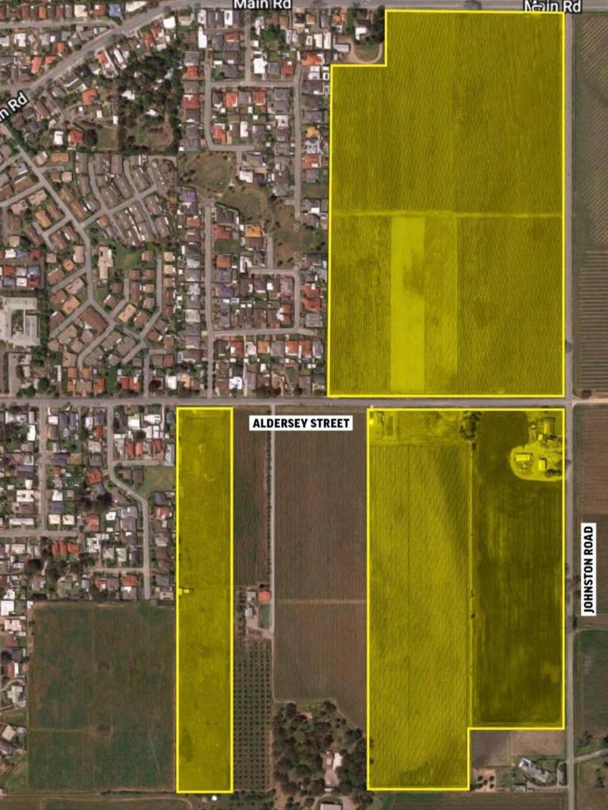
The parcels of land in question. Picture: Leon Bignell Facebook

Meanwhile, Narungga MP Fraser Ellis wants the EFPA protections extended to the northern Yorke Peninsula region to safeguard it from housing development and mining.
“I understand the regions were not originally included in the boundaries because EFPAs are intended to protect land from urban encroachment, but having said that, I submit that they should now be expanded to cover our regional areas,” he wrote in a letter to Ms Chapman.
“If this valuable land is worth protecting from one use, it is worth protecting from others.”
South Australian Chamber of Mines and Energy chief executive officer Rebecca Knol said Mr Ellis’ letter “is again seeking to progress an agenda to implement a (farmer’s) right to veto”.
“Agriculture on the Yorke Peninsula currently supports approximately 1000 workers,” she said.
“In contrast, the proposed Hillside Mine which will occupy the area of two small farms (south of Ardrossan, and accounts for) approximately 0.2 per cent of the arable area of the Yorke Peninsula, will directly employ up to 500 workers.”
A state government spokeswoman said regional areas were not included in EFPAs because they were protected through zoning.
“The Yorke Peninsula, aside from townships, is covered by the Rural Zone which seeks to support the area’s economic prosperity,” she said.
“It does this by setting out various controls in relation to preserving rural land for primary production activities. This includes setting additional limits around land division and use of land.”
Mr Bignell claimed the state government was “sneakily” using the review of the EFPAs to also look at amending character preservation areas, saying the Liberals were “always eager to look after their developer mates more than the people of our area”.
He is holding a public meeting to discuss the review on Wednesday at 6pm in the Tatachilla Lutheran College gym. RSVPs are essential due to Covid restrictions.
A previous review of CPDs in 2018 prompted 500 McLaren Vale residents to attend a public meeting, organised by Mr Bignell, to voice their opposition to any changes to the boundaries.
Dudley Brown, 58, owns Inkwell Wines and boutique accommodation Hotel California Road. He said it would be “terrible” if the parcels of land were subdivided for housing.
“It would be bad for tourism and it would be bad for investment because people would stop investing,” he said.
A SPC spokeswoman said the commission was investigating the merits of requests to amend the boundaries of the CPD of eight locations, in line with a recommendation from a 2018 review of CPD in 2018.
She said the commission had “not yet formed a view on the merits of otherwise” of the requests and it welcomed feedback through its public consultation process.
Planning Minister Vickie Chapman said it was “outrageous” that Mr Bignell claimed the government “sneakily” using the review to reassess boundaries.
“The facts are that the State Planning Commission’s review into the Environment and Food Production Areas has been instigated by laws passed by the previous government and any proposed reforms will require the parliament’s approval,” she said.

